

**CST 3130 Advanced Web Development**

**with Big Data**

**Coursework 2: Visualisation of Data**

**2021 Oct Intake**

**Muddathir Muhammad Ibney Noorani Joomun**

**(M00830556)**

Contents

1. Description 3

2. Objectives 3

3. Key Features 4

4. Numerical Data Source 4

5. Sentiment Analysis Data Sources 5

6. Wireframes 5

7.Static Website on AWS 6

7.Conculsion 6

Table of Figures

Figure 1. Wireframe 5

Figure 2. Static Website 6

# 1. Description

Cryptocurrencies have become a significant force in finance, drawing attention from investors and enthusiasts. Our project aims to provide a powerful platform for in-depth analysis and visualizations of five major cryptocurrencies. By leveraging AWS for cloud services and TypeScript for coding, we integrate sentiment analysis and machine learning to empower users with real-time insights and predictions, facilitating informed decision-making in the dynamic cryptocurrency landscape.

**Data and Analysis:**

Our platform sources numerical data from leading cryptocurrency exchanges, offering live and historical information for enhanced market understanding. In addition to key metrics like Market Cap 24 hrs, All-Time High, Market Price, Market Cap, and Volume, we introduce a dedicated section for Positive Sentiment. This section utilizes sentiment analysis on textual data from diverse sources like news APIs and social media, providing a comprehensive view of market sentiment. Integrated machine learning algorithms, powered by AWS SageMaker, enhance our predictive capabilities, offering users valuable insights into future price trends. This fusion of AWS cloud services, TypeScript coding, sentiment analysis, and machine learning positions our platform as an accessible and sophisticated tool for navigating the cryptocurrency market..

# 2. Objectives

The primary objectives of our project include

1. Offering comprehensive numerical data displays for five selected cryptocurrencies, incorporating live prices and historical data.
2. Implementing sentiment analysis by sourcing text data from diverse platforms to gauge market sentiment for each cryptocurrency.
3. Utilizing machine learning algorithms to predict future price trends for individual cryptocurrencies.
4. Displaying synthetic data to validate the accuracy of predictions and visualizations.
5. Storing all relevant data securely in the cloud, leveraging the AWS Educate account for efficient cloud services.
6. Implementing a serverless architecture using Lambda functions for scalability, cost-effectiveness, and efficient data handling.
7. Developing an engaging front-end using JavaScript or a chosen framework, enriched with WebSockets for seamless real-time updates.
8. Employing infrastructure-as-code frameworks like AWS SAM or www.serverless.com for streamlined infrastructure management.

# 3. Key Features

1. Numerical Data Display

Live and historical data for five cryptocurrencies, ensuring accuracy and real-time updates.

1. Sentiment Analysis:

Leveraging text data from various sources to provide sentiment analysis for market sentiment understanding.

1. Machine Learning Predictions:

Utilizing machine learning algorithms to predict future price trends for each cryptocurrency, aiding users in decision-making.

1. Synthetic Data Display:

Displaying synthetic data to validate the accuracy of predictions and visualizations, ensuring reliability.

1. Cloud-based Storage:

Securely storing data in the cloud, with AWS Educate account usage for cloud services.

1. Serverless Architecture:

Utilizing Lambda functions for a serverless architecture, ensuring scalability and cost-effectiveness.

1. Front-end Development:

Developing an engaging front-end with JavaScript or a chosen framework, incorporating WebSockets for real-time updates.

1. Infrastructure-as-Code:

Implementing AWS SAM or www.serverless.com for efficient infrastructure management.

# 4. Numerical Data Source

1. Cryptocurrency Exchanges

Cryptocurrency exchanges are platforms where users can buy, sell, and trade digital assets. Exchanges like Coinbase, Binance, Kraken, Bitstamp, and Gemini provide real-time and historical price data for various cryptocurrencies.

1. Coinbase
2. Binance
3. Kraken
4. Bitstamp
5. Gemini
6. Cryptocurrency APIs:

Cryptocurrency APIs (Application Programming Interfaces) offer developers access to data related to digital assets. APIs such as CoinGecko, CoinMarketCap, CoinAPI, and Nomics provide information on prices, market capitalization, trading volumes, and more.

1. CoinGecko API
2. CoinMarketCap API
3. CoinAPI
4. Nomics API

# 5. Sentiment Analysis Data Sources

Cryptocurrency-specific News Platforms:

Cryptocurrency-specific news platforms like CoinTelegraph, NewsBTC, and CryptoSlate focus on news and analysis within the crypto space. These platforms provide insights into industry-specific events, regulatory changes, and market trends.( One of Below Shall be used)

* CoinTelegraph
* NewsBTC
* CryptoSlate
* X

# 6. Wireframes

Below you shall find the wireframe for the Project. This is for 1 currency same will just update based on which cryptocurrency is selected in the dropdown

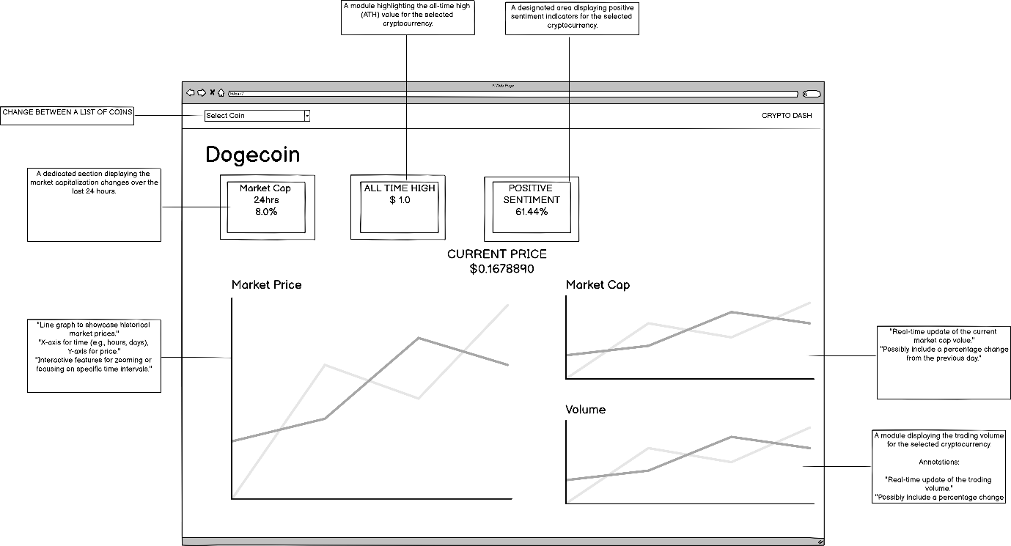

Figure 1. Wireframe

# 7.Static Website on AWS

Below is the screenshot of the statics website on AWS S3

Link is <https://m00830556.s3.amazonaws.com/index.html>

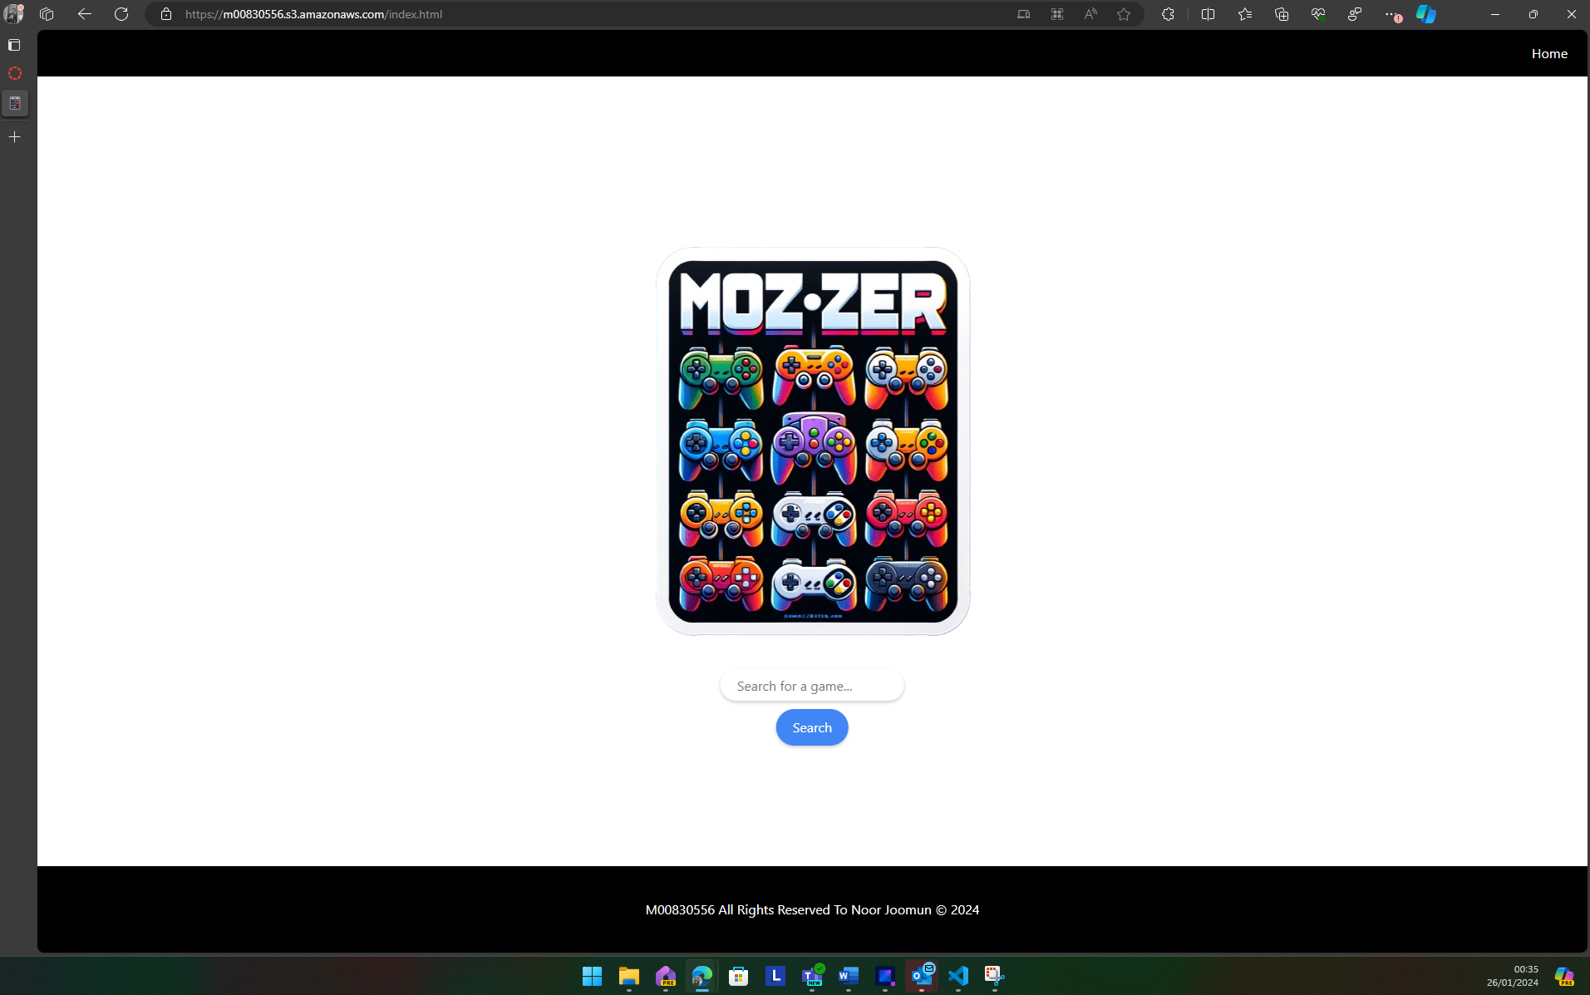

Figure 2. Static Website

# 7.Conculsion

In summary, our project blends AWS and TypeScript to create a user-friendly platform for cryptocurrency analysis. Key metrics like Market Cap, Volume, and sentiment analysis offer a holistic view of market dynamics. The Positive Sentiment section adds an innovative touch. As we conclude, our platform strives to be a practical tool for informed decision-making in the ever-changing cryptocurrency landscape. We look forward to showcasing its impact in the final demonstration.